**DOKUZ EYLUL UNIVERSITY**



**ENGINEERING FACULTY**

**DEPARTMENT OF COMPUTER ENGINEERING**



**CME1252 PROJECT BASED LEARNING – II**

**FINAL REPORT**

**PROJECT – III**

**WORD PUZZLE**

**By**

**Sadullah CİHAN**

**Zeynep ÖZTÜRK**

**Enes Niyazi BALTACI**

**Lecturers**

**Assoc. Prof. Dr. Derya BİRANT**

**Res. Asst. Feriştah DALKILIÇ**

**May, 2020**

**İZMİR**

**Page**

**CONTENTS**

**CHAPTER ONE**

**INTRODUCTION 1**

**CHAPTER TWO**

**PROJECT DESCRIPTION 2**

**CHAPTER THREE**

**TASK SUMMARY** **3-4**

3.1. Completed Tasks 3-4

3.2. Incomplete Tasks: Reasons and Explanations 4

3.3. Additional Improvements to the Project 4

**CHAPTER FOUR**

algorıthms and solutıon strategıes…………...………………….5

**CHAPTER FIVE**

**PROBLEMS ENCOUNTERED AND CHANGES IN REQUIREMENTS 6**

**CHAPTER SIX**

**OVERALL ASSESSMENT OF THE PROJECT 7**

**REFERENCES 8**

**POSTER OF THE PROJECT……………………………………………………...9**

**TRELLO MESSAGES…………………………………………………………10-11**

# CHAPTER ONE

INTRODUCTION

This is the Word Puzzle project progress report of Dokuz Eylul University Department of Computer Engineering. The project period is 4 weeks. The aim of this project is to develop a two-player game that guesses correctly the specific words in the puzzle table. This project aims to develop a two-player game that guesses correctly the specific words in the puzzle table.

Word Puzzle is a two-player game. The game is played on a 15x15 puzzle screen. Also, a player can guess the Turkish meaning of the completed word. At the end of the game, the high-score table is shown to users. In this project, Single Linked List data structure has been implemented to sort words alphabetically. Multi Linked List data structure has been implemented to list words sequentially. Double Linked List data structure has been implemented to sort the high-score table.

# CHAPTER TWO

## PROJECT DESCRIPTION

Word puzzle game consists of a puzzle matrix (15 x 15), a word list (dictionary, max. 100 words), a solution matrix (15 x 15) depends on puzzle matrix, a high score table, given as text files, with the names puzzle.txt, word_list.txt, solution.txt and high_score_table.txt respectively. The puzzle.txt file includes binary values where the 1s symbolize the letters and 0s indicate empty spaces. After these files are read, the screen is designed and the game starts. Users can also write their names at the beginning of the game.

Each player guesses a letter from the word list and try to find a word. When a player places a letter in a position, if the placement is correct, the player gets point and continues to insert letters, if it is inappropriate, the turn goes to the second player. The second player tries to guess another word by placing a letter. The player gets one point for each correct action. A word is completed when its last letter is guessed. The player who completes a word gets 10 points. Then, the completed word’s Turkish meaning is asked for the user. If the user guesses the correct answer, takes 10 extra points. When all the words are completed on the board, the game ends and the player who has the highest score wins the game and replace on the high scoreboard.

# CHAPTER THREE

TASK SUMMARY

## Completed Tasks

Completed Tasks By Sadullah CİHAN

Necessary classes and variables have been created for the project. For instance, ThePuzzleGame, Player, Single Linked List (SLL), Double Linked List (DLL), Multi Linked List (MLL), and WordPuzzleTest classes have been created. The game screen has been designed. Cursor movement has been implemented. All needed text files have been read. Additionally, “readAllRequiredFiles”, “thePuzzleGame”, “letterControls” methods have been implemented. The program has been tested correctly without bugs, design errors. Letters and word controls have been accomplished on SLL and MLL. After the implementation of “letterControl(Player p)” method, the player’s scores have been calculated and added their scores. “TurkishMeaning(String answer, Player p)” method has been implemented to ask the completed word’s Turkish meaning to the user. “highScore(Player p)” method has been implemented to print the high-score table. “addBetween(Object dataToAdd)” method has been implemented to add the winner user name and score sequentially in the DLL class. Additionally, the poster of the Word Puzzle has been designed.

Work Done By Zeynep ÖZTÜRK

Required classes have been created. The input files are read and relative information has been stored in their corresponding data structures. Cursor movement on the board has been completed. SLL and MLL implementations have been accomplished. Designing of the double linked list and implementation of the high score table has been accomplished. Additionally, the presentation of the Word Puzzle has been accomplished.

Work Done By Enes Niyazi BALTACI

Necessary classes have been created so far. Text files have been read and have been added them into necessary structures. They stand in SLL and MLL with alphabetic order. The game board has been created. Also, wordlist has been sorted and words have been controlled.

## Incomplete Tasks: Reasons and Explanations

There are not any incomplete tasks. All requirements have been fulfilled as wanted.

## Additional Improvements to the Project

Additional Improvements By Sadullah CİHAN

“writeToFile(String path, String newTxtContent)” method has been implemented to rewrite the high-score table to the text file.

createSolutionSll() method has been implemented. Solution SLL has been created from solution array to check the completed word’s correction easier.

# CHAPTER FOUR

algorıthms and solutıon strategıes

Firstly, creating solution strategies are discussed with the project. Then, researches have been done. All needed text files are read according to “UTF-8” [1]. That is why Turkish characters are read correctly.

Secondly, both for the screen and the puzzle board necessary methods have been created. All words which inside the “word_list.txt” are inserted alphabetically to Single Linked List which name is “wordListSequent”. The “compareTo()” function has been used to add alphabetically. Then, this list has been inserted to general Multi Linked List which name is “mllWordList”.

Thirdly, all correct word’s first letters are got from solution array to create solution Single Linked List. The array has been scanned for 97-122 interval sequentially. These numbers are ASCII codes for the alphabet [2]. Thereby, word list which will reflect the user has been added to “solutionSll”. The screen has been printed by using “printScreen()” function. Puzzle array and player’s scores are displayed in this function.

Fourthly, at the beginning of the letterControl(Player p) function design, horizontal and vertical word pattern have been kept on 2 different String. Then the pattern has been taken and searched from mllWordList with searchWord(String inputWord) function on MLL class. If the taken letter is in the correct position on the correct word, the user gets 1 point for each correct letters. At the end of the function, if all word correct, turkishMeaning(String answer, Player p) function is started.

Lastly, two different random Turkish words have been found with using “findRandomTurkishWord” function on MLL. Then options are assigned randomly and asked to the user the Turkish meaning of the completed word. According to answer user gets 10 points. If the game has ended, the high-score table is printed, saved to “highScoreDll”. Then the updated high-score table written to the text file.

# CHAPTER FIVE

PROBLEMS ENCOUNTERED and Changes In RequIrements

The first problem that the project team encountered is displaying Turkish letters. Because English letters are supported by java.io library; therefore, this problem is solved “UTF-8” conversion [1].

The second problem that the project team encountered is blocking the cursor movement of the user. In the beginning, the user can write anywhere that he or she wants; however, the problem has been solved with ASCII codes [2]. Finally, the user just writes alphabet to proper word’s part.

The final problem that the project team encountered is array out of bounds exceptions. While the program is taking a word pattern, an array size may not be sufficient; hence, array size can be overrated. However, the problem is solved with boundary controls in “if blocks”.

For the 2 last project's weeks, 2 new requirements have been informed; printing all word list and writing high-score table to the text file. The implementation of these requirements has taken two days. Now, word list can be displayed correctly and the high-score table can be written to the text file with the correct order.

# CHAPTER SIX

Overall Assessment of the Project

All wanted missions have been accomplished as in the plan respectively. Problems encountered are also resolved. The knowledge of SLL, MLL, and DLL have been improved on project team vision dramatically.

REFERENCES

1. Java Read Write UTF-8 Encoded Data, Lokesh Gupta, Retrieved 1 May 2020 from

<https://howtodoinjava.com/java/io/how-to-read-write-utf-8-encoded-data-in-java/>

1. 7-bit ASCII Character Codes, Unknown, Retrieved 1 May 2020 from

<https://www.sciencebuddies.org/science-fair-projects/references/ascii-table>

**APPENDIX A : POSTER OF THE PROJECT**

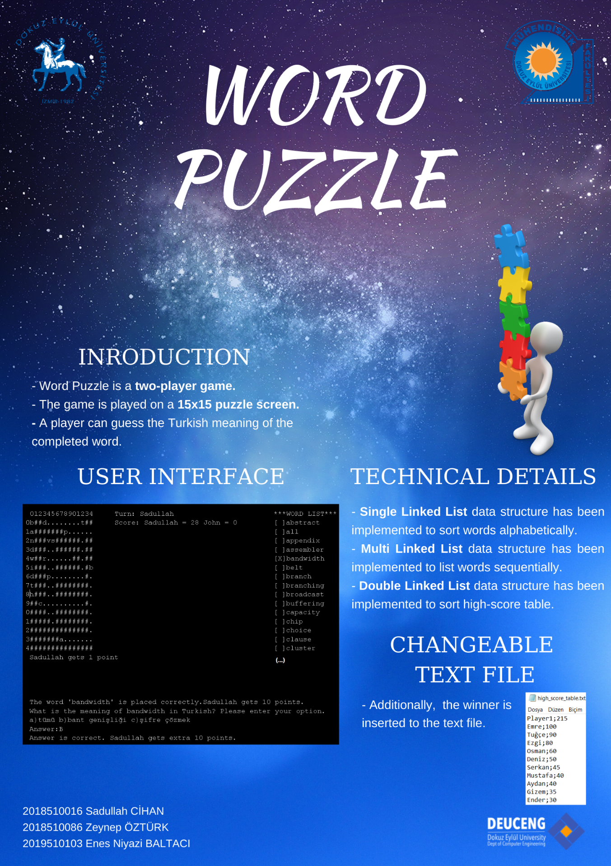

**APPENDIX B: TRELLO MESSAGES**

